Bachelor’s Studies

Field: Quantitative Methods in Economics and Information Systems
Specialization.……………………

Author’s Name and Surname: Lena Kulikowska
Student No.: 122230

“Impact of Socioeconomic and Individual Factors on Voter Turnout. A Statistical Analysis Using European Social Survey Data.”

Bachelor’s thesis
under scientific supervision of
Dr. Dawid Majcherek
Department
Of International Management
The Collegium Of World Economy

Warsaw 2025

Table of contents
Introduction 4
Methods 9
Path analysis 9
Regression 11
Dataset 18
Main information 19
Descriptive statistics 21
Results 28
Model 1 28
Model 2 31
Discussion of results 32
Conclusion 34
Bibliography: 35
List of tables: 37
List of figures: 38
A Supplement: Survey 39

Introduction

Participating in elections is a fundamental aspect of democracy. In democratic countries, citizens are expected to be able to vote and select their representatives. As a result, voter turnout becomes a key issue in politics. It can be defined as the proportion of citizens who vote in elections among those who have the legal right to do so (Blais, 2000). It is believed that voting is the most common and frequent form of political engagement. Additionally, it is the only form of political participation where everyone has an equal influence. What is more, turnout may be perceived as an indicator of social connectedness and trust in a society (Crothers and Lockhart, 2000; Huddy and Khatib, 2007)
Nevertheless, many individuals still refrain from voting. Turnout levels tend to fluctuate over time, vary across different types of elections within a country, and differ between nations. Therefore, understanding who votes and what conditions encourage electoral participation appears to be crucial question for social scientists and analysts.
Analyzing and collecting comprehensive data on voter turnout helps to ensure that elections are free, fair, and accessible to all citizens. High turnout levels indicate that decisions regarding political leadership are made by a representative group of citizens and not only by the elites (Lijphart, 1997). In contrary, low turnout may lead to governance that does not fully represent interests of the whole population. Widespread abstention becomes an even greater issue when the same groups of citizens consistently refrain from voting for many years, as it leads to increasing social and political disparities between voters and non-voters (Martikainen et al., 2005). Moreover, low turnout is often related to voter disengagement and distrust in the political system (Solijonov, 2016). Hence, it can be observed that high participation in elections is desirable. The decreasing voter turnout in many established democracies has raised serious concerns among election stakeholders and analysts.
When it comes to European Union member states, from the end of World War II until 1959, voter turnout averaged 84.7 percent. During the economic boom from 1960 to 1973, it remained nearly unchanged at 85.6 percent. Even when economic conditions worsened due to rising oil prices, global recession, and inflation, turnout remained relatively stable, averaging 83.9 percent in the period between 1974 and 1987. Nevertheless, a noticeable drop in voter turnout has been evident since 1988, with an average of 78 percent, which remained rather constant until 2003 (Rose, 2003). The negative trend in voter turnout in European Union member states continued since then. Between 2022-2025 the average turnout reached approximately 63 percent (IDEA Voter Turnout Database, 2025). Nevertheless, despite obvious decline in some European countries, such as for instance Austria, Bulgaria, Finland, Netherlands, Italy, and Portugal, there still exist countries in which turnout has fluctuated significantly in both directions, showing no consistent trend. Examples of such nations can be Belgium, Croatia, Denmark, Germany, Greece, Hungary, Ireland, Lithuania, Poland, and Spain (IDEA Voter Turnout Database, 2025).
Scholars have proved the importance of institutional variables in predicting citizens’ decision regarding participation in elections. It can be observed that in recent decades, there has been a significant rise in the number of democratic countries. Especially in Europe, the year 1989 was a turning point in its postwar history. The fall of Berlin Wall signified the end of communist regimes in Eastern Europe (Schöpflin, 1990). As a result, a substantial number of individuals have gained the chance to express their real views. Despite this, still many voices go unheard, leading to inadequate representation. This implies that not only institutional and political factors shape voter engagement (Solijonov, 2016). Hence, it is crucial to examine other potential determinants of turnout.
Engaging in political activities, such as voting requires both time and resources. Anthony Downs’s An Economic Theory of Democracy (as cited in Bergson, 1958) explains that political participation is often seen as irrational because the personal costs of involvement usually exceed the impact that an individual can have on final decisions of the government. Consequently, rational individuals will opt out of participation and finally benefit from the efforts of others without contributing themselves. Nevertheless, still many citizens continue to take part in political activities (Potgieter, 2013). Hence, the decision to engage in politics goes beyond purely self-interested considerations, suggesting that social and psychological factors also play a central role and cannot be overlooked (Dalton, 2008; Levy and Akiva, 2019).
According to Snyder, (2011) the most fundamental aspects of civic engagement are individual-level factors. The author claims that demographic and socioeconomic factors are commonly recognized as being closely linked to voting behavior and political awareness. Moreover, focusing on these aspects helps to address the root causes of political disengagement, as it reveals why some individuals are more prone to participate in elections than others. Verba et al. (1972) develop the SES (socioeconomic status) model of political participation, which focuses on impact of variables like education, income and occupational status on political activity, including voting. The authors discover that there exists a positive relationship between socioeconomic status and voter turnout in the United States. Similarly, Martikainen et al., (2005) examine the association of socioeconomic factors with voter turnout in Finland. Their research proves that turnout is clearly higher among individuals from more privileged socioeconomic backgrounds. In contrary, Tambe (2016) conducts research on voter turnover in East Asia and obtains different results. The author employs socioeconomic factors as independent variables and finds out that they do not have a statistically significant impact on voter turnout.
Institutional factors shape the structure of participation in elections. Moreover, citizens often tend to act rationally by voting to maximize their personal benefits. However, individual characteristics determine who ultimately decides to vote. Therefore, the aim of this paper is to primarily focus on demographic and socioeconomic predictors of voter turnout.

The related literature often investigates the relationship between levels of education and voter turnout. Education has long been considered a key factor in explaining the likelihood of voting (Snyder, 2011). According to Powell (1986), a person with a ninth-grade education is 10 percent more likely to vote than someone with just a sixth-grade education. What is more, this likelihood grows with higher levels of education. High school graduates are 17 percent more likely to vote, and those who completed college are 35 percent more likely to vote than those with only a sixth-grade education. Similarly, many other researchers argue that higher levels of education positively affect an individual’s likelihood of participating in elections (Milligan et al., 2004, Smets and Van Ham, 2013, Wolfinger et al., 1980). They attribute this connection to the idea that education provides people with the necessary resources for involvement and equips them with civic skills essential for effective expression of their political views (Potgieter, 2013). Moreover, academics suggest that education plays a key role in helping citizens to develop their knowledge and abilities needed to engage in political issues (Berinsky and Lenz, 2011).

Another consistently documented relationship in the field of political behavior is the strong correlation between income and participation in politics. Rosenstone, (1982) states that there are two perspectives which explain possible effect of income on voter turnout. One point of view may be perceived as “mobilization”. It suggests that financial hardship leads to greater political participation. It argues that citizens facing economic difficulties hold the government responsible for their situation and respond by voting and engaging in other forms of political action to address their concerns. However, an alternative approach suggests that individuals facing financial hardship are less likely to participate in politics. This perspective claims that economic struggles create stress and a focus on personal financial well-being rather than on political matters. This means that those in poverty are more likely to be absorbed in personal financial concerns than the general population (Rosenstone, 1982). This statement is supported by Schafer et al. (2022). The authors employ panel data from Bologna in northern Italy. They discover that economic hardship not only reduces turnout in the short term, but it also has a long-term negative influence on social connections and institutions that are crucial to maintain a high-quality democracy. Moreover, Filer et al. (1993) state that majority of cross-sectional studies, which focus on variation in voter turnout, discover that participation tends to be greater among individuals with higher income. However, Chang, (2014) obtains quite distinct results in research concerning voter turnout in Taiwan. The empirical findings of this study indicate that income has minimal influence on voter turnout. Nevertheless, there exists a weakly statistically significant effect with respect to lower-middle class, which appears to have the highest probability of refraining from voting. It means that the poorest individuals do not have the lowest likelihood of participating in elections. What is more, we may suspect that the relationship between income and likelihood of voting in elections is in fact nonlinear. Income impacts voter turnout only up to the point where a reasonably comfortable standard of living is achieved. Beyond this threshold, additional income no longer affects the probability of voting (Wolfinger et al., 1980).

Moreover, age may potentially be an important factor in explaining voter turnout. Related research consistently shows that voter participation varies across different age groups. These studies indicate that the youngest eligible voters are the least likely to participate in elections, while middle-aged individuals have the highest voting rates. Additionally, older adults tend to vote more frequently than young adults. Research has also often shown that voter turnout peaks among individuals in their fifties (Glenn and Grimes, 1968). In his paper, Potgieter (2013) explains that as people grow older, they take on greater family, work, financial and social obligations, making politics more significant and influential in their lives. In addition, turnout gradually increases with age, peaks in the forties and fifties, and finally steadily declines after sixties (Potgieter, 2013).

Research concerning voter turnout that analyses micro-level data also often employs gender as one of regressors. Many researchers try to discover whether there exists a gender gap in voting. Stockemer et al. (2023) argue that classic cross-national survey research regarding gender disparities in voting proves that men tend to have higher likelihood of participating in elections than women. Decades ago, lower turnout among women was seen as a natural outcome of their delayed political inclusion and disparities in resources (Dassonneville and Kostelka, 2021). Nevertheless, gender trends in voter turnout in established democracies have evolved. Recent research indicates that the traditional gap between men and women has either disappeared or that women now have a slightly higher likelihood of voting than men. By analyzing survey data and official electoral records, Stockemer et al. (2023) come to conclusion that in fact women, on average, vote more. They try to explain this phenomenon theoretically, while saying that female citizens may have a higher sense of civic duty. Dassonneville et al. (2021) agrees with the thesis of greater proportion of women in voter turnout in Europe, but only in certain types of elections. The authors emphasize that while women vote at equal or higher rates than men in national elections, their participation is lower in supranational elections, for example to European Parliament.

According to related literature national identity can be a factor that drives political participation. Huddy et al. (2007) examine how attachment to a country influences political engagement, measured among other factors by voter turnout. The authors hypothesize that according to social identity theory, individuals with a strong national identity tend to be more politically active because they are more likely to follow group norms. Their research reveals that national identity appears to be a significant predictor of voter turnout. The coefficient for this variable is positive, which implies that greater attachment to a country leads to higher likelihood of voting in national elections. However, what is interesting, the authors discover that extremely high levels of national identity (referred to as uncritical patriotism or nationalism) in fact have a negative impact on voter turnout (Huddy and Khatib, 2007). In contrary, Kim (2023) finds out that uncritical patriotism can boost voter turnout in some young democratic nations that grew out of economically successful authoritarian regimes.

Studies focusing on individual-level determinants of voting participation also often include political interest as one of predictors. Tambe (2016) uses micro-level data and logistic regression to analyze the impact of political interest on probability of participating in elections in East Asia. The author does not find statistically significant effect of this variable on voter turnout in the whole region. Nevertheless, while analyzing Japan separately, such relationship can be confirmed. The author discovers that there exists a positive influence of political interest on likelihood of voting by individual in this country. Similarly, Snyder, (2011) employs political knowledge as independent variable in a model that explains voter turnout. The author finds out that political knowledge is a statistically significant predictor, and that more knowledgeable respondents are more likely to vote. Moreover, Solijonov (2016) emphasizes that societies can increase voter participation by fostering citizens’ interest in politics through measures such as civic education in schools and promoting a transparent environment that encourages political discussion and debate.

The aim of this paper is to examine individual-level factors influencing electoral participation, and to assess whether these determinants align with patterns identified in existing literature. The following sections outline variable selection, data sources and analytical approach used in this research.

Methods
Why do some people vote, and others abstain? This question is fundamental to the study of public choice. According to existing literature, education, income, gender, age, attachment to a country and political interest appear to be statistically significant determinants of electoral participation in a substantial portion of related research. The aim of this part of the thesis is to outline the expected causal effects between predictors and dependent variable, and to describe the methodology that will be used to perform the analysis.

Path analysis
Firstly, it is crucial to identify a path analysis, which is a statistical technique for examining relationships among a set of observed variables (Valenzuela and Bachmann, 2017). As depicted in the literature review, voter turnout may be influenced by numerous factors. Variables such as age, attachment to a country, education, gender, income, and political interest may be crucial in explaining the variation in the likelihood of voting, and they may directly impact voter turnout. Hence, in this analysis voter turnout is applied as a dependent variable, while characteristics of individuals mentioned above are predictors (Figure 1.).

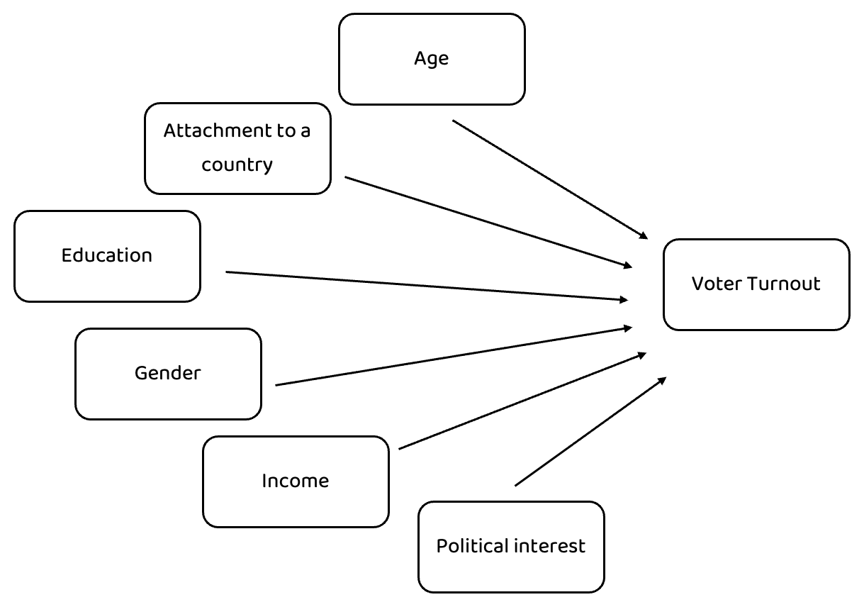
Figure 1: Direct relationships between the predictors and dependent variable. Source: Own elaboration.

What is more, in this problem also indirect relations between the predictors and dependent variable can be identified. Firstly, age may be a strong predictor of education. When it comes to young individuals, as people get older, they typically complete higher levels of education. However, as far as older individuals are concerned, once people finish their formal education, their education remains fixed, and age does not significantly affect it anymore. Then, a substantial amount of research and literature proves that education is a statistically significant determinant of income. For instance, this relation was captured by Palaščáková (2020), who obtains the Pearson correlation coefficient r = 0.969, which indicates a strong positive relationship between the average gross monthly income and education level in Slovakia. In addition, r = 0.969 suggests an almost perfect direct linear dependence between the variables, as it is very close to 1 (Ratner, 2009). Hence, individuals with higher levels of education are more likely to have well-compensated jobs (Palaščáková, 2020). Finally, income potentially directly influences voter turnout, as described earlier in the literature review (Chang, 2014; Filer et al., 1993; Rosenstone, 1982; Schafer et al., 2022). This path is presented in the Figure 2 below.

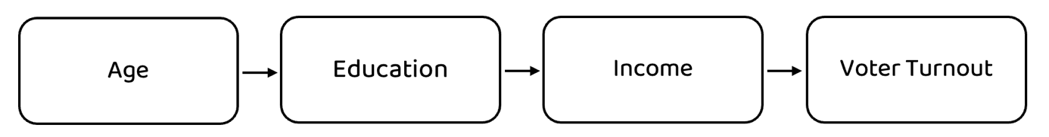

Figure 2: Path 1: Indirect relationships between predictors and dependent variable. Source: Own elaboration.

Furthermore, education may be a potential determinant of political interest. Education plays a crucial role in increasing political awareness. Through schools and universities, individuals are exposed to knowledge about political systems, historical contexts, and current events. This process helps them to develop a deeper understanding of governance, civic responsibilities, and societal issues (Kattimani, 2012). Ultimately, political interest may influence participation in elections, as described in the related literature (Snyder, 2011; Tambe, 2016). Such path is presented in the Figure 3. below.

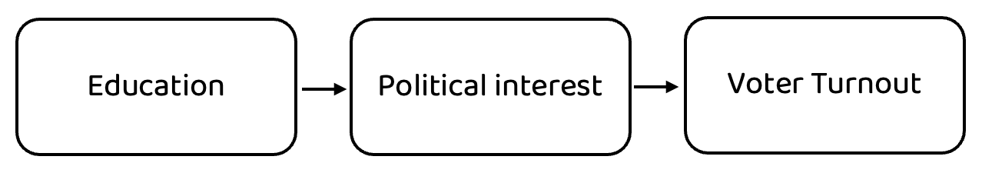
Figure 3: Path 2: Indirect relationships between predictors and dependent variable. Source: Own elaboration.

In addition, an impact of gender on income can be proved, for instance due to the existence of the so-called gender pay gap. The gender pay gap is the difference in average gross hourly earnings between women and men. The average gender pay gap in the European Union was equal to 12 percent in 2023, which means that women earned on average 12 percent less per hour than men in 2023 (Eurostat, 2023). There exist various reasons for the existence of gender pay gap. For example, on average, women do more hours of unpaid work, such as childcare and housework. Moreover, women are more likely to experience career interruptions, often due to childbearing. Thirdly, approximately 24 percent of the overall gender pay gap is due to the high concentration of women in lower-paying sectors (European Parliament). Finally, as mentioned in the literature review, income becomes a direct determinant of likelihood of voting in elections (Figure 4.).

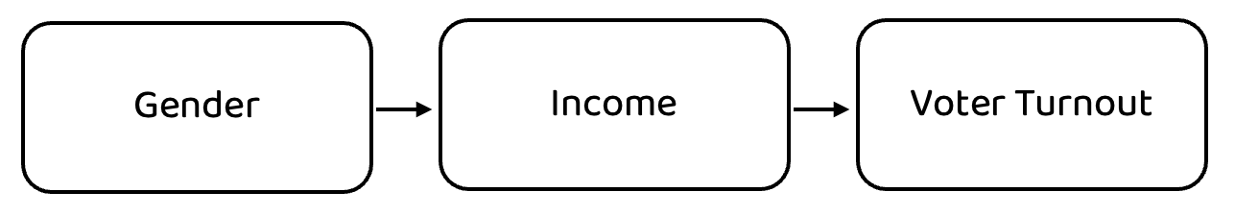
Figure 4: Path 3: Indirect relationships between predictors and dependent variable. Source: Own elaboration.

Finally, a relationship between age and attachment to a country can be identified. Attachment to a country can be also expressed as patriotism. Research on national identity and attachment indicates that older individuals ten to express greater national pride and patriotism, often shaped by their historical experiences and longer life in a given society. For instance, in Great Britain, younger people display lower levels of patriotism than older generations. According to data from polling firm YouGov, only 15 percent of those aged 18-24 identify as “very patriotic”, compared to nearly half of those aged over 60. In addition, only a small portion of those over 60 years old stated that they were not patriotic at all, whereas this statement was shared by up to 16 percent of individuals aged 18-24 (Sehmer, 2015). This path can be identified in the Figure 5.

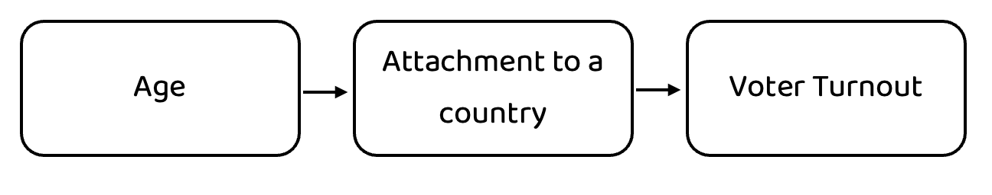
Figure 5: Path 4: Indirect relationships between predictors and dependent variable. Source: Own elaboration.

Such path analysis and identifying indirect relationships allow for a deeper understanding of causality. What is more, it is crucial to distinguish the presence of mediators from multicollinearity. However, the issue of collinearity will be further explained in the part with the results of analysis.

Regression
A substantial fraction of research that examines voter turnout using survey data employs logistic regression (Chang, 2014; Filer et al., 1993; Martikainen et al., 2005; Tambe, 2016). Similarly, the aim of this study is to analyse individual-level determinants of electoral participation in national elections using logistic regression. Hence, the dependent variable in this analysis is voting behavior, represented as a binary variable vote. It takes value equal to 1 if a person, eligible to vote, voted in the last national elections in their country, and 0 otherwise. As far as explanatory variables are concerned, this study includes six predictors.
Firstly, age is a continuous variable, which describes the age of respondent. Nevertheless, it may be beneficial to transform it into categorical variable. According to existing literature, voter turnout tends to rise gradually with age, reaching its highest levels for people in their fifties, and then steadily declining after sixties (Potgieter, 2013). Hence, categorization could potentially prevent from a misleading assumption of linearity. As depicted in the Figure 6. the relationship between the log odds of voting and age is not strictly linear.

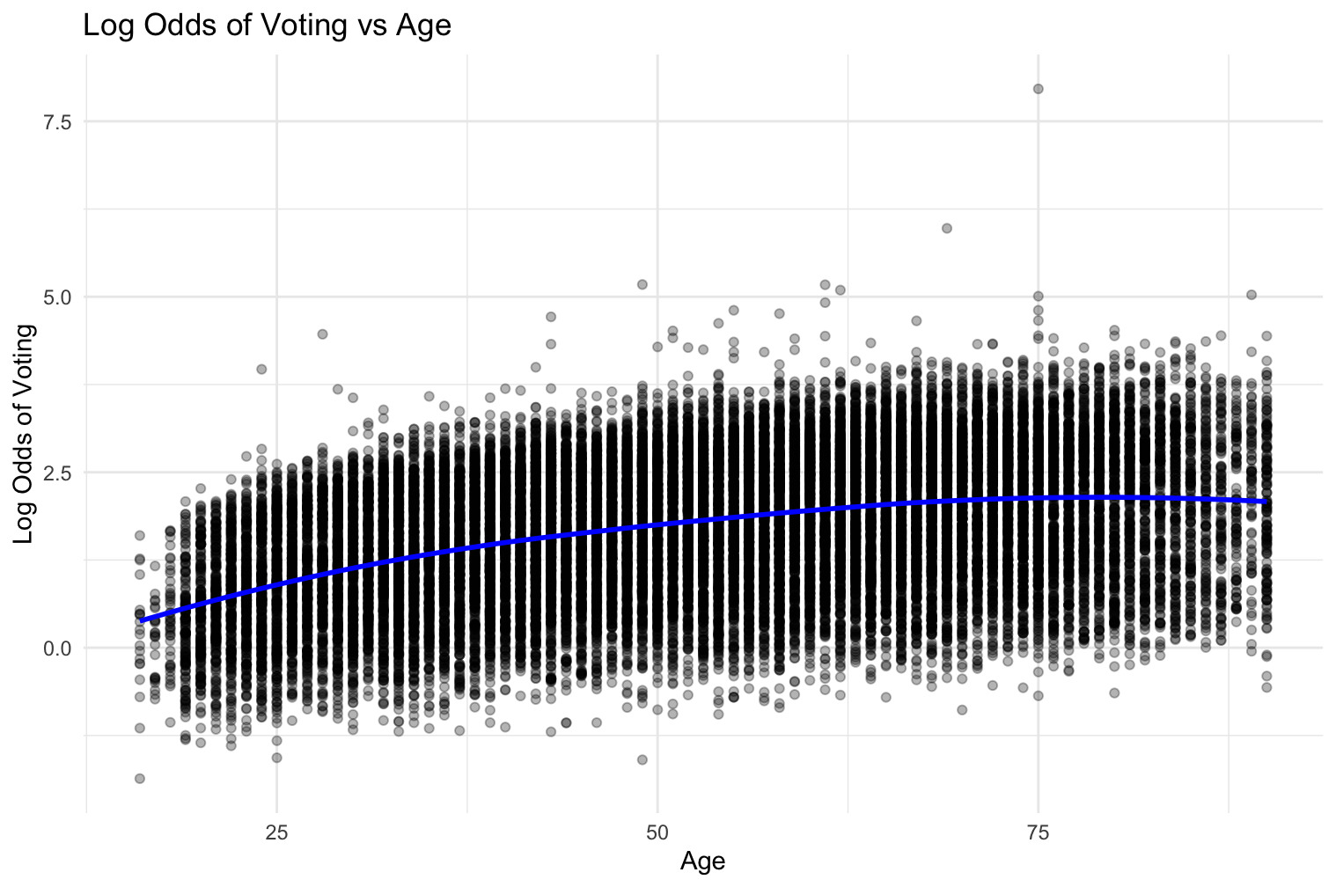
Figure 6: Relationship between the log odds of voting and age. Source: Own elaboration.

Moreover, transforming continuous variables into categorical ones may allow for the calculation of odds ratios for specific categories (Andrade, 2021). Hence, variable age can be classified into four distinct groups: 16-29 (young adults), 30-49 (middle-aged adults), 50-64 (pre-retirement age) and 65 and above (senior citizens). Such classification would allow to create dummy variables (age_16_29, age_30_49, age_50_64, and age_65plus), which could be included in the logit model. In logistic regression, one category must be selected as the reference group, which serves as a reference point against which the effects of other age groups are compared. Here, Category 3 will serve as a reference category. This implies that variable age_50_64 will be dropped in the regression to make the model full-rank and avoid collinearity (Carnegie Mellon University). The summary of transforming continuous variable age into categorical one can be observed in the Table 1. below.

New category | Variable | Age Range | Description
Category 1 | age_16_29 | 16-29 | Young adults, early career stage
Category 2 | age_30_49 | 30-49 | Middle-aged adults, working professionals
Category 3 | age_50_64 | 50-64 | Pre-retirement, peak earning years
Category 4 | age_65plus | 65 and above | Seniors, retired or near retirement
Table 1: Age categorization. Source: Own elaboration.

Furthermore, atchctr is a variable, which reflects how emotionally attached a person feels to their country. To answer this question, respondents were asked to choose a number from 0 to 10, where “0” stands for not at all emotionally attached and “10” means very emotionally attached. In the logistic regression model atchctr will be treated as a continuous variable, although it is based on a discrete Likert scale. After comprehensive literature review, it may be expected that there exists a positive relationship between attachment to a country and voter turnout.
Then, eduyrs is a continuous variable that helps to capture the level of education of a person. In this case, respondents were asked a question “About how many years of education have you completed, whether full-time or part-time?”. Respondents had to report these years in full-time equivalents and include compulsory years of schooling. According to the existing literature, a positive relationship is expected, which implies that the more time a person spends in education, the higher their likelihood of casting a ballot. When it comes to this study, the positive linear relationship between the log odds of voting and education years is presented in the Figure 7.
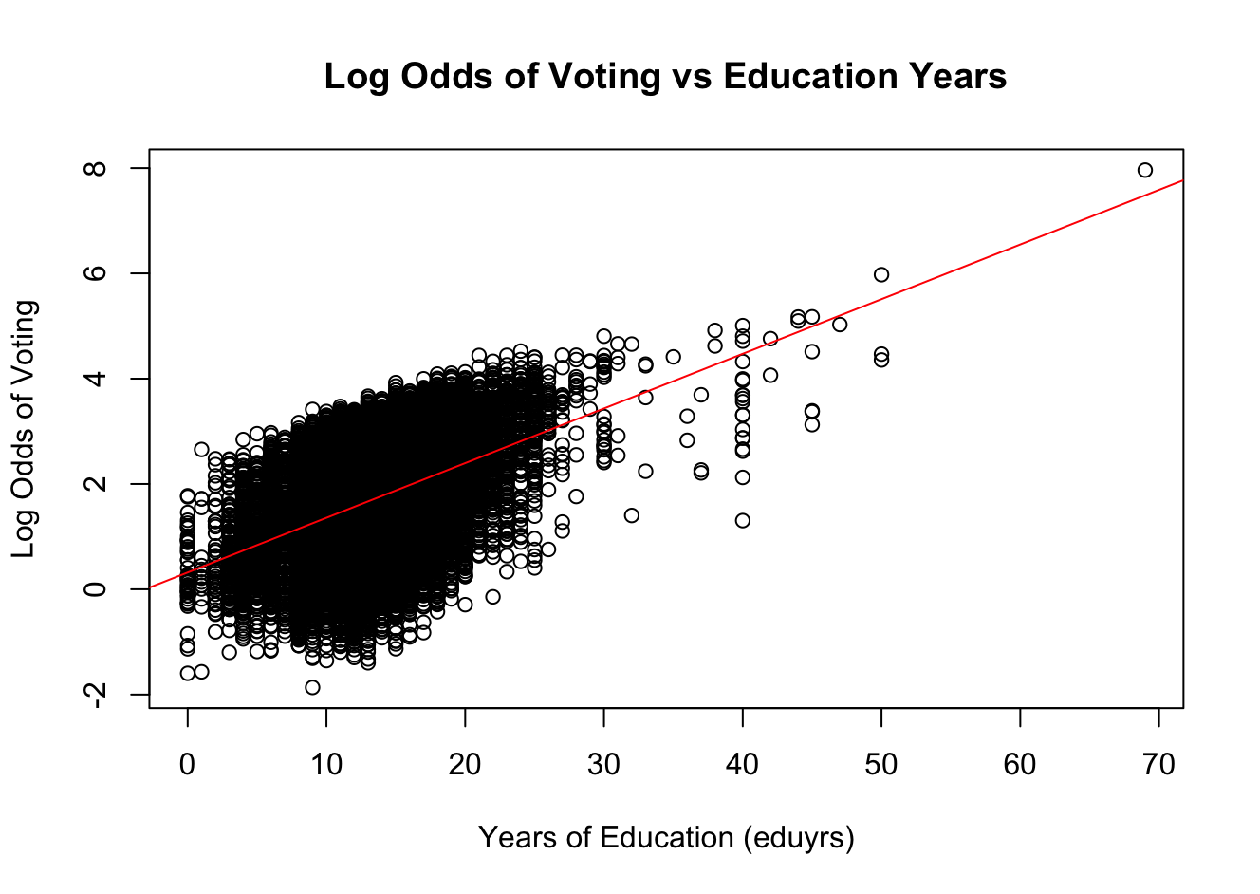
Figure 7: Relationship between the log odds of voting and education years. Source: Own elaboration.

Moreover, studies on voter turnout also frequently include gender as a key predictor. Therefore, gender is employed in this study as a binary independent variable, which takes a value of “1” for males and “0” for female respondents. The related literature emphasizes that in the past, men used to report higher voter turnout. However, in recent years, women have voted at equal or even higher rates than men. Hence, it is difficult to predict a causal relationship between gender and voter turnout. Nevertheless, a negative relationship can be expected based on contemporary theories, meaning that women may be more likely to vote than men.
What is more, understanding economic situation of an individual may be beneficial to explain the variation in probability of participating in elections. Therefore, a categorical variable income is applied. In this case, respondents were asked about household’s total net income (after tax and compulsory deductions) from all sources. They had to indicate in which decile they would find themselves, using appropriate letters (J, R, C, M, F, S, K, P, D, H). Each decile contains 10 percent of the population. For instance, the first decile represents the lowest 10 percent of income earners, while the 10th decile contains the highest 10 percent of income earners. However, these ten deciles can be recategorized into five categories by grouping every two deciles into one category. This operation may simplify the income distribution while preserving income differences (Table 2.).

New Category | Variable | Original Deciles | Description
Category 1 | d1 | 1st and 2nd decile (J, R) | Lowest 20 percent of income earners
Category 2 | d2 | 3rd and 4th decile (C, M) | 20-40 percent of income earners
Category 3 | d3 | 5th and 6th decile (F, S) | 40-60 percent of income earners (middle income)
Category 4 | d4 | 7th and 8th decile (K, P) | 60-80 percent of income earners
Category 5 | d5 | 9th and 10th decile (D, H) | Top 20 percent of income earners
Table 2: Income recategorization. Source: Own elaboration.

Regrouping the ten income deciles into five broader categories is also useful to create dummy variables (d1, d2, d3, d4, d5), which correspond to each category. Dummy variables allow categorical income data to be included in the model. Here, Category 1 will serve as a reference group and variable d1 will be dropped in the regression model. Given that d1 is used as the reference group, the coefficients for d2, d3, d4, and d5 in the model are expected to be positive, suggesting a higher likelihood of voting as income increases. In addition, since higher-income individuals tend to have higher voting rates, the effect should be the strongest for d4 and d5, representing the top 40 percent of income earners.
Furthermore, political interest is a key factor in predicting various political behaviors. This analysis uses categorical variable polintr to describe how interested a person is in politics. Here, respondents were asked a question “How interested would you say you are in politics”. The values of this variable range from 1 to 4, where: “1” – very interested, “2” – quite interested, “3” – hardly interested, “4” – not at all interested. In this case higher numbers are associated with lower interest in politics. It may be counterintuitive, especially when comparing with variable atchctr, where higher numbers indicate stronger attachment to a country. Therefore, it would be beneficial to reverse the scale of variable polintr so that higher values represent more intensive political interest, aligning with atchctr. Such operation would make the interpretation of results more consistent and intuitive. Hence, the following transformation can be applied (Equation 1.).

$$polintr_reversed=5-polintr$$
Equation 1: Scale transformation for variable polintr. Source: Own elaboration.

As a result, the values of responses would change, as depicted in the Table 3.
Transformation | Description
1 ⇒ 4 | very interested
2 ⇒ 3 | quite interested
3 ⇒ 2 | hardly interested
4 ⇒ 1 | not at all interested
Table 3: Reversing the scale of categorical variable polintr. Source: Own elaboration.

Finally, the summary of all variables needed for conducting the analysis of the likelihood of voting can be observed below (Table 3.).

Variable | Description | Continuous/Categorical/Binary Variable
vote | Whether a respondent voted in the last national elections (dependent variable) | Binary variable, “1” – Yes, “0” - No
age | Age of a respondent | Continuous variable
age_group | Age classified into four groups | Categorical variable, 4 distinct groups: 18-29, 30-49, 50-64, 65+
age_16_29 | Whether a respondent is between 16 and 29 years old | Binary variable, “1” - Yes, “0” – No, reference category
age_30_49 | Whether a respondent is between 30 and 49 years old | Binary variable, “1” - Yes, “0”- No
age_50_64 | Whether a respondent is between 50 and 64 years old | Binary variable, “1” - Yes, “0”- No
age_65plus | Whether a respondent is between 65 years old or above | Binary variable, “1” - Yes, “0”- No
atchctr | How emotionally attached a respondent is to their country | Continuous variable, “0” – not at all emotionally attached, “10” – very emotionally attached
eduyrs | How many years a respondent spent in education | Continuous variable (years)
gender | Gender of a respondent | Binary variable, “1” – Male, “0” – Female
income | Household’s total net income from all sources (after tax and all compulsory deductions) | Categorical variable, grouped into ten deciles
income_category | Income classified into five groups | Categorical variable, 5 distinct categories, each containing 2 subsequent income deciles
d1 | Whether a respondent belongs to the 1st or 2nd income decile | Binary variable, “1” – Yes, “0” - No
d2 | Whether a respondent belongs to the 3rd or 4th income decile | Binary variable, “1” – Yes, “0” - No
d3 | Whether a respondent belongs to the 5th or 6th income decile | Binary variable, “1” – Yes, “0” - No
d4 | Whether a respondent belongs to the 7th or 8th income decile | Binary variable, “1” – Yes, “0” - No
d5 | Whether a respondent belongs to the 9th or 10th income decile | Binary variable, “1” – Yes, “0” - No
polintr | How interested a respondent is in politics | Categorical variable, “1” – very interested, “4” – not at all interested
polintr_reversed | How interested a respondent is in politics (reversed scale) | Categorical variable, “1” – not at all interested, “4” – very interested
Table 3: Summary of all variables needed for the analysis. Source: Own elaboration.

Dataset
Selecting the proper dataset is crucial for the analysis, as it directly impacts the validity, reliability and quality of research findings. The aim of this part of thesis is to provide an overview of the dataset used in the study.

Main information
This study uses data, which comes from the European Social Survey Data Portal. The European Social Survey (ESS) is an academically driven, cross-national survey. It has been conducted across European countries since its establishment in 2001. Every two years, it gathers data through face-to-face interviews. Hence, every two years a new round of the survey is created. The aim of the European Social Survey is to create a reliable dataset that allows academics, researchers and policy makers to map and measure social attitudes, beliefs, behaviors across European nations. Respondents are selected by random probability methods at every stage using sampling frames of individuals, households or addresses. It ensures that the sample accurately represents the broader population and reduces biases. The respondents represent the entire residential population aged 15 years old and above in each country.
This study uses the 11th round (2nd edition) of the European Social Survey, which was published in November 2024. As far as its geographical scope is concerned, it contains data gathered from 24 countries. The total sample size is equal to 40,156 respondents. The figure below summarizes the percentage share of each country in the survey (Figure 8.). It can be noticed that Italy (7.1 percent) and Greece (6.8 percent) have the highest participation rates, while the lowest can be observed for Cyprus (1.7 percent) and Iceland (2.1 percent). Nevertheless, the goal of this study is to analyse individual-level factors affecting voter turnout across Europe in general, without distinguishing between individual nations.

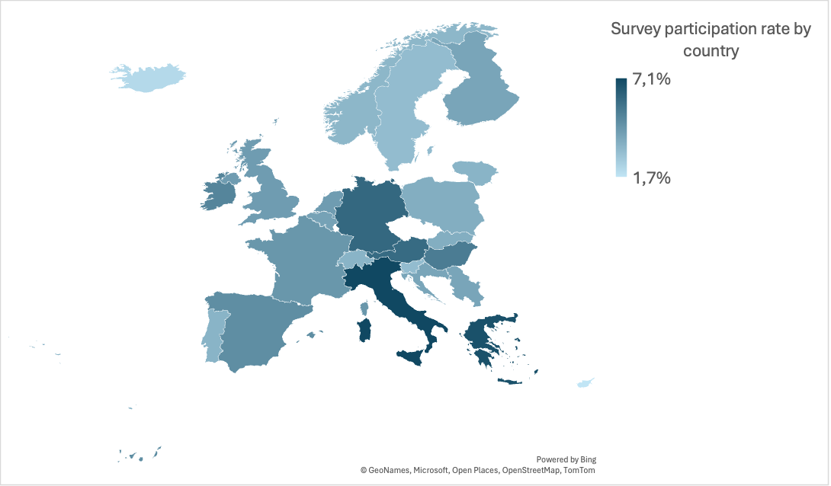
Figure 8: Survey participation rate by country. Source: Own elaboration.

Data cleaning
The target in the analysis is the likelihood of an individual voting in the national elections. In the European Social Survey respondents were asked whether they voted in the last national elections. Their responses were coded as follows (Table 4.).

Value | Category
1 | Yes
2 | No
3 | Not eligible to vote
7 | Refusal
8 | Don’t know
9 | No answer
Table 4: Coding of responses regarding voting in the last national elections. Source: Own elaboration.

It is crucial to include in the study only individuals that are eligible to vote. Moreover, the final dataset excludes rows with information “Refusal”, “Don’t know” and “No answer”. Hence, only answers coded “1” or “2” are taken into consideration.
Similarly, as far as independent variables are concerned, the final dataset excludes all rows containing codes for responses such as “Refusal”, “Don’t know” and “No answer”. This step is justified because such answers are always coded with numbers. Hence, applying them in the dataset could distort further analysis and interpretation of results. Moreover, removing these missing values does not significantly change the percentage share of individual countries in the dataset. As a result, no country is excluded, preventing potential sampling bias. Therefore, the final size of the dataset is equal to 29,268 observations. It may also be beneficial to depict and influential observations. However, this operation will be described in the part concerning results of the study.

Descriptive statistics
As the dataset is already clean and complete, descriptive statistics can be computed. Firstly, when it comes to the dependent variable, the share of those who voted in the last national elections and those who refrained may be observed in the figure below (Figure 9.). It can be noticed that the share of those who participated in the elections is significantly higher than the share of those who refrained from voting. This suggests that the sample is imbalanced, as the distribution of observations for vote variable is very unequal (i.e. substantially larger proportion of ones than zeros in the dataset). Nevertheless, logistic regression is generally robust to such imbalanced data. For estimating the vector of parameters in the logistic regression model, the maximum likelihood estimator (MLE) is used (Krzyśko and Smaga, 2018). It is asymptotically the most efficient estimator, which means that the maximum likelihood estimates (MLE) of a logistic regression model are biased only for small sample sizes (Salas-Eljatib et al., 2018). Hence, for large samples (as in this study) this bias diminishes.

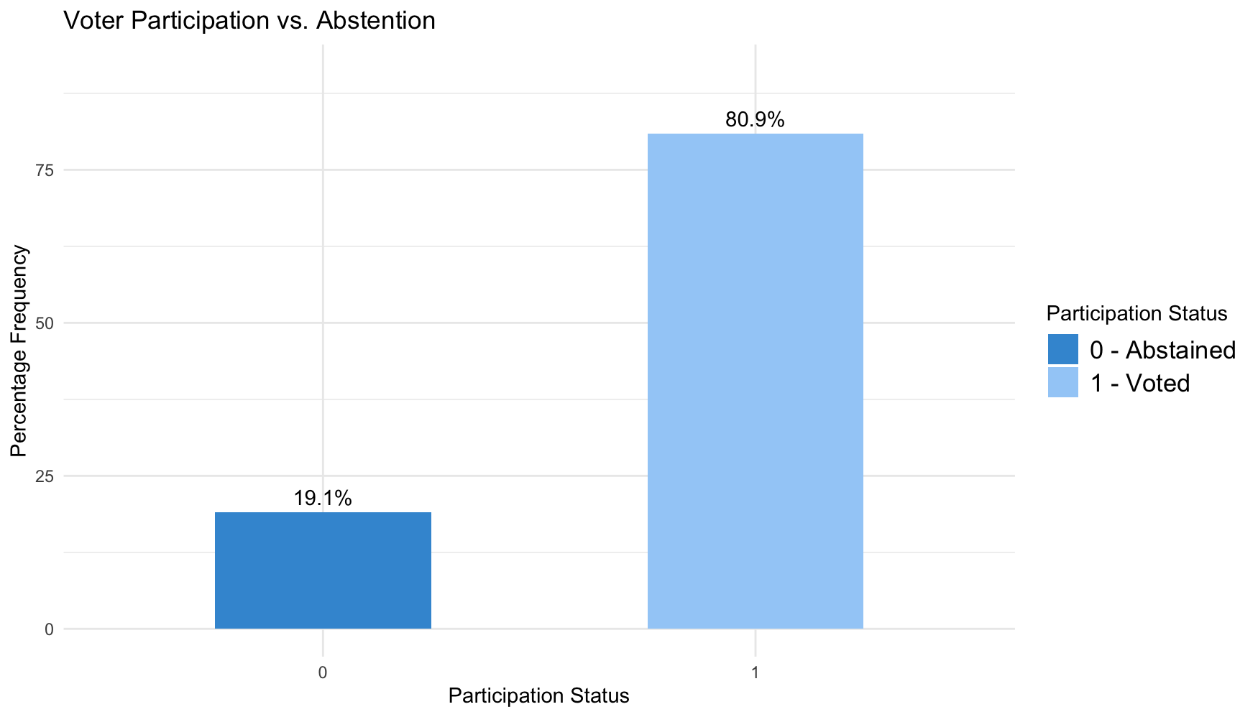
Figure 9: Share of respondents who voted and abstained in the last national elections. Source: Own elaboration.

When it comes to initially continuous variable age, the distribution of respondents’ age can be analyzed (Figure 10.). It can be observed that the distribution if the data is left-skewed or negatively skewed. This indicates that most observations are concentrated at the higher end, while a smaller number of lower values extend the left tail. As a result, the mean is lower than the median, as the presence of younger individuals with relatively low values decreases the mean (Iacobucci et al., 2025). The descriptive statistics for this variable may be observed in the Table 5. below. What is interesting, the minimum observed value is 16 years. This is because the minimum voting age in national elections varies by country with the lowest being 16 in Austria and Belgium. In addition, 17-year-olds can vote in Greece (European Commission). Furthermore, as described previously, it may be beneficial to categorize continuous variable age. Hence, Figure 11. presents the distribution of distinct age categories in the sample.

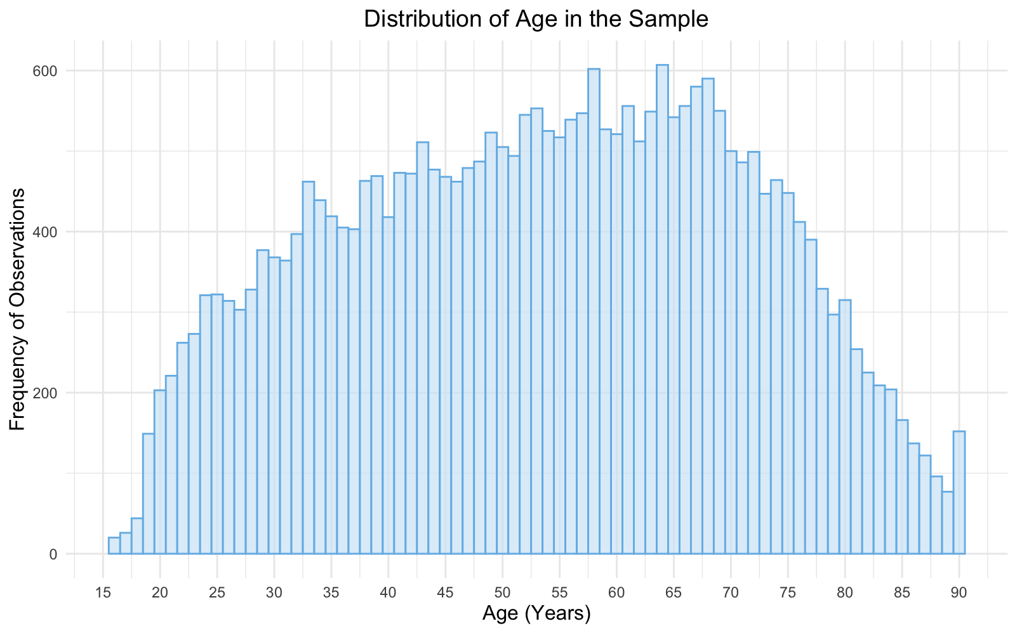
Figure 10: Distribution of age in the sample. Source: Own elaboration

Variable | Min | First Quartile (Q1) | Median (Q2) | Mean | Third Quartile (Q3) | Max
age | 16 | 39 | 54 | 53.55 | 68 | 90
Table 5: Descriptive statistics for variable age. Source: Own elaboration
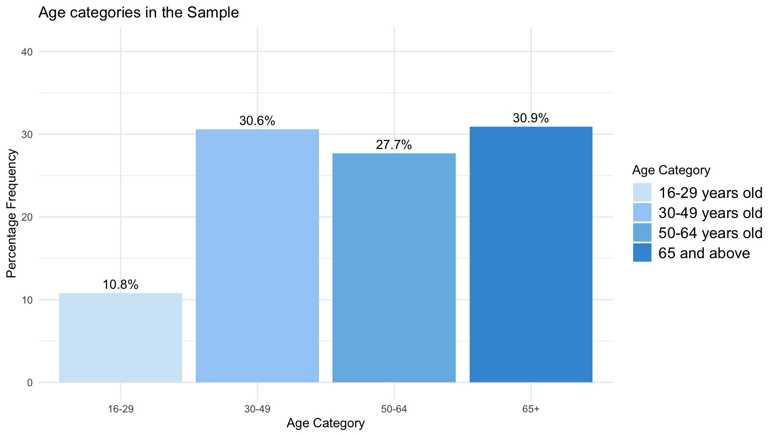
Figure 11: Age categories in the sample. Source: Own elaboration.

Similarly, as far as time spent in education is concerned, a histogram and descriptive statistics can be computed. When it comes to the distribution of data (Figure 12.), it appears to be positively skewed, which means that most data points are on the lower end, with fewer, yet extreme values on the higher end (Iacobucci et al., 2025). Moreover, as the minimum observed value is equal to 0 years, and maximum amounts to 69 years, it may hypothetically suggest the presence of outliers within the dataset (Table 6.).
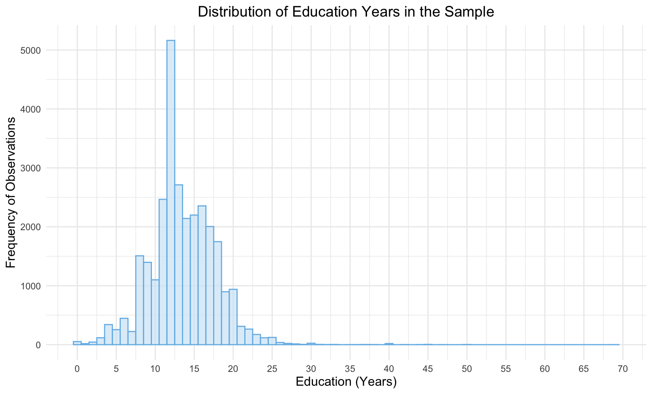
Figure 12: Distribution of education years (eduyrs) in the sample. Source: Own elaboration.

Variable | Min | First Quartile (Q1) | Median (Q2) | Mean | Third Quartile (Q3) | Max
eduyrs | 0 | 11 | 13 | 13.54 | 16 | 69
Table 6: Descriptive statistics for variable eduyrs. Source: Own elaboration.

When it comes to variables such as atchctr (attachment to a country), income and polintr (political interest), the frequency of responses is presented in the Figures 13., 14., and 15. below. Firstly, as far as political interest is concerned, the highest share of respondents declares that they are hardly interested in politics. Then, regarding income, the highest proportions can be observed in the 6th, 7th and 8th deciles. Finally, when it comes to attachment to a country, a substantial fraction of surveyed individuals appears to be very emotionally attached to their country (29.8 percent), while only 1.2 percent of the total sample states that they are not attached to their country at all. Nevertheless, as described previously, atchctr will be applied in the logistic regression as a continuous variable because the distance between points is roughly equal. This means that one point increase in attachment to a country from “4” to “5” is interpreted similarly to the increase from “7” to “8”. Moreover, Rhemtulla et al. (2012) discover that if ordinal variable has at least five categories, employing it as a continuous one improves efficiency and simplicity of estimation.

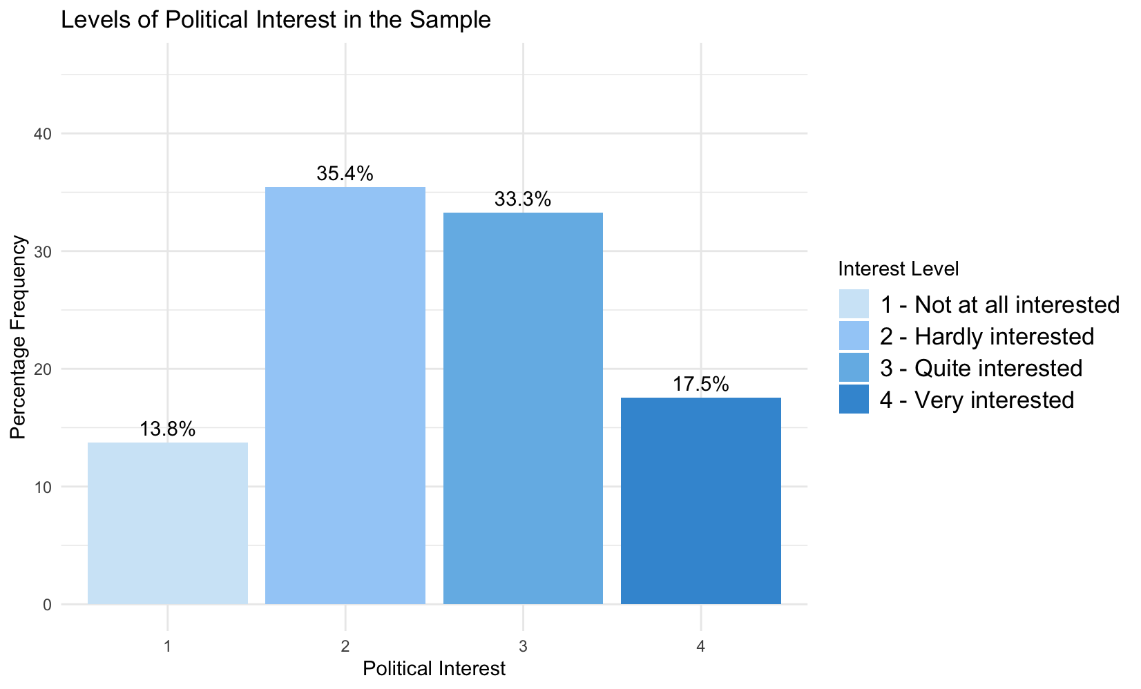
Figure 13: Political interest among respondents. Source: Own elaboration.

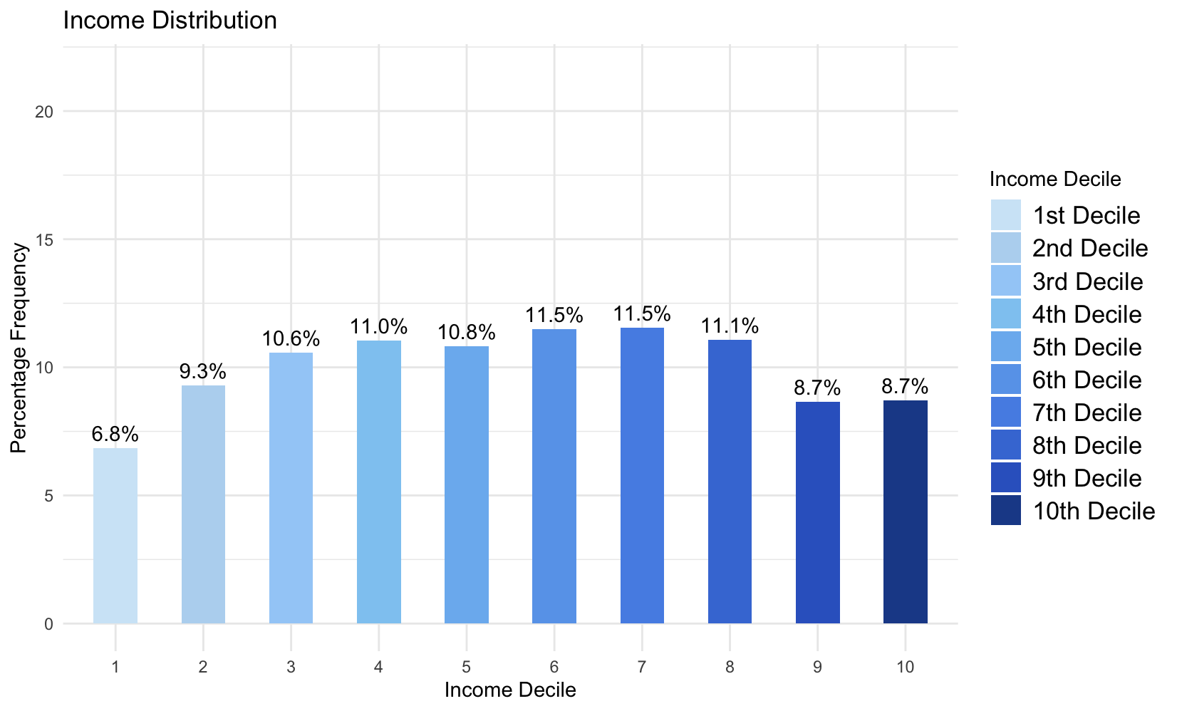
Figure 14: Income distribution in the sample. Source: Own elaboration.
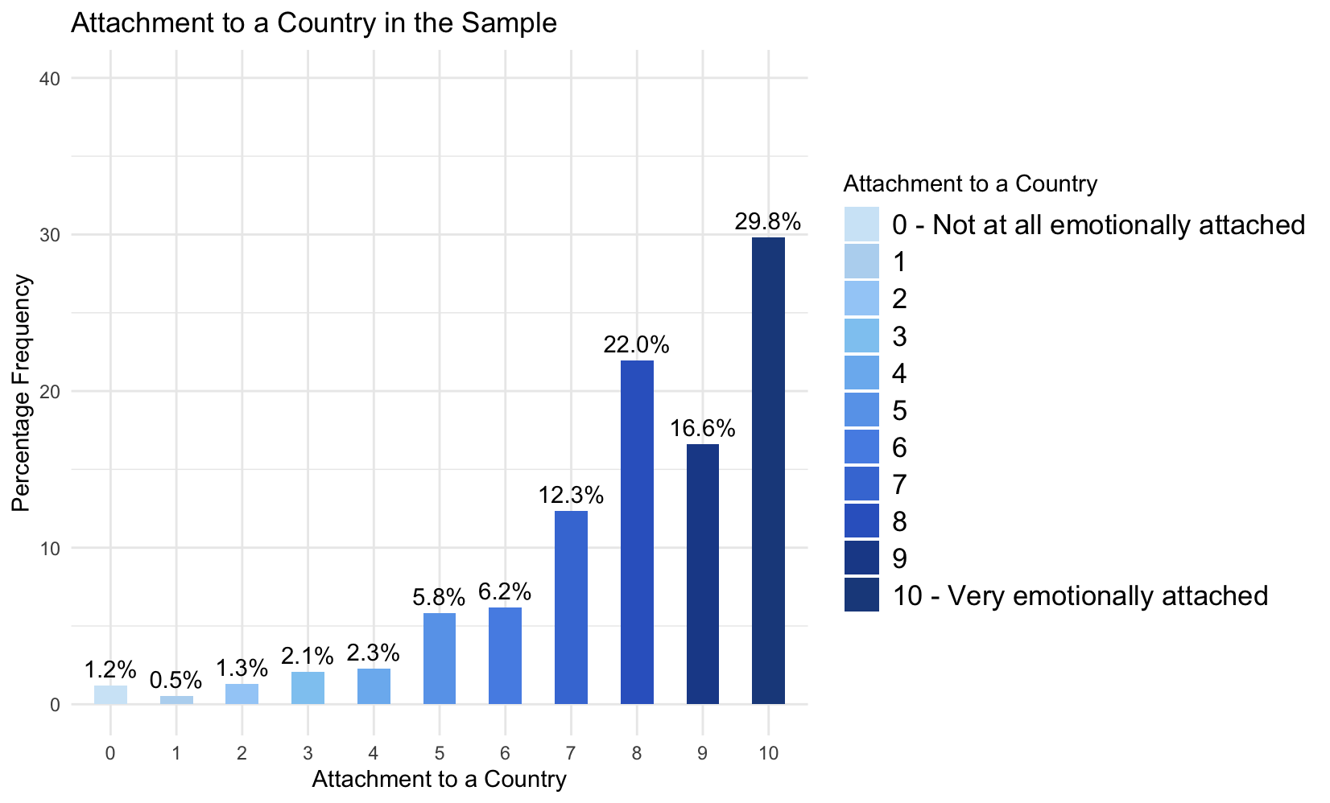
Figure 15: Attachment to a country in the sample. Source: Own elaboration.

Regarding gender distribution, the final dataset consists of 52.8 percent females and 47.2 percent male respondents (Figure 16.). There is a slight difference between the number of female and male survey participants. What is interesting, a gender gap in survey participation is often observed. There exist theories which explain this phenomenon. Firstly, men potentially face higher opportunity costs when participating in surveys, as women are more likely to stay at home. As a result, women tend to be more accessible and available for survey participation (Becker, 2022). Secondly, higher educational level is often linked to increased survey participation. Since women generally achieve higher educational levels than men, this helps to explain their greater involvement in surveys (Becker, 2022).

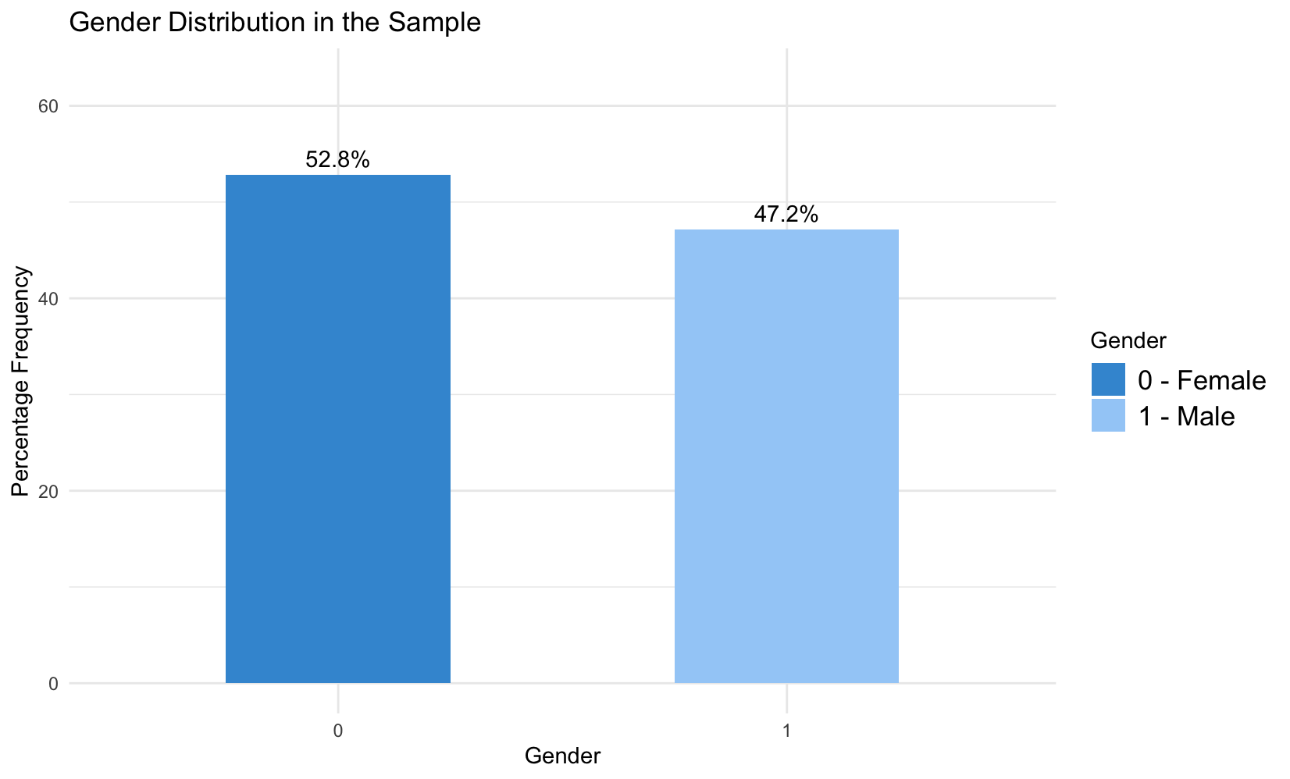
Figure 16: Share of men and women in the sample. Source: Own elaboration.

Results
Logistic regression is well suited for analyzing and evaluating hypotheses regarding the relationships between a categorical dependent variable and one or more independent variables, which may be either categorical or continuous. In this study, the logit model takes the form as in the Equation 2. The aim of this part of the thesis is to present the results of performed logistic regression analysis.
$$p=P\left(vote=1 \right| X)= \frac{1}{1+e^{-(β0+ β1x1+ β2x2+…+ βkxk)}}$$
Equation 2: Logit model formula. Source: Stanford University.

Model 1
The first model has beeen created using the dataset consisting of 29,268 observations. Estimation results can be observed in the Table 7.
Logistic Regression Results (Model 1)
Predictors | Coefficient | Std. Error | t-statistic | p-value | CI Lower | CI Upper
(Intercept) | -1.462 | 0.092 | -15.816099 | 0.000 | -1.644 | -1.281
polintr_reversed2 | 0.739 | 0.039 | 19.020921 | 0.000 | 0.663 | 0.815
polintr_reversed3 | 1.614 | 0.046 | 34.758380 | 0.000 | 1.523 | 1.705
polintr_reversed4 | 1.918 | 0.073 | 26.119085 | 0.000 | 1.775 | 2.063
gender1 | -0.088 | 0.033 | -2.681872 | 0.007 | -0.152 | -0.024
eduyrs | 0.078 | 0.005 | 16.266700 | 0.000 | 0.069 | 0.087
atchctr | 0.102 | 0.007 | 14.583161 | 0.000 | 0.089 | 0.116
age_16_29 | -0.828 | 0.053 | -15.732172 | 0.000 | -0.931 | -0.725
age_30_49 | -0.457 | 0.043 | -10.644212 | 0.000 | -0.542 | -0.373
age_65plus | 0.387 | 0.047 | 8.171822 | 0.000 | 0.294 | 0.480
d2 | 0.325 | 0.049 | 6.645491 | 0.000 | 0.229 | 0.420
d3 | 0.415 | 0.051 | 8.219515 | 0.000 | 0.316 | 0.514
d4 | 0.514 | 0.053 | 9.705202 | 0.000 | 0.410 | 0.618
d5 | 0.637 | 0.060 | 10.536055 | 0.000 | 0.519 | 0.756
Observations | 29 268
McFadden R² | 0.135
Table 7: Logistic regression results (Model 1). Source: Own elaboration.

In the first model, all of independent variables appear to be statistically significant based on t-test, as p-values are lower than significance level equal to α = 0.05. Moreover, to evaluate how well the model fits the data, one may use the so called Pseudo-R², also known as the McFadden R² (Equation 3.). In this measure, lnL_{UR} is the log-likelihoood for the estimated model, and lnL₀ is the log-likelihood function in the model with only an inctercept (Wooldridge, 2012). Therefore, this measure allows to compare the fit of the full model relative to a baseline model that uses no explanatory variables.
$$R2MF= 1- \frac{lnLUR}{lnL0}$$
Equation 3: McFadden R² (Pseudo-R²). Source: Wooldridge (2012). Introductory Econometrics. A Modern Approach, 5th Edition.

In the first model (Table 7.), McFadden R² is equal to 0.135, and it measures how much better the fitted model performs compared to the baseline “null” model. Hence, a Pseudo-R² of 0.135 suggests that the predictors in the model provide a 13.5 percent improvement in the log-likelihood over the null model. What is important, McFadden R² typically yields low values. According to the literature, Pseudo-R² value between 0.2 and 0.4 usually suggests that the model fits the data well (Lee, 2025). Therefore, a value equal to 0.135 indicates a sub-optimal fit.
Moreover, it is important to check for collinearity, which occurs when two variables are nearly perfect linear combinations of each other. In addition, multicollinearity arises when multiple variables in a regression model are strongly correlated not only with the dependent variable but also to each other. Multicollinearity can lead to unreliable estimates and distorted variance calculations, which influences confidence intervals and hypotheses tests (Midi et al., 2010). To detect collinearity, Variance Inflation Factor (VIF) can be computed (Shrestha, 2020). According to James et al. (2013), VIF > 5 is cause for concern, and VIF > 10 indicates a serious collinearity problem. The Table 8. summarizes Variance Inflation Factors for the first model (Model 1). It can be observed that the issue of collinearity is not present (VIF < 10).

Variance Inflation Factor
Predictors | VIF
polintr_reversed | 1.11
gender | 1.04
eduyrs | 1.37
atchctr | 1.04
age_30_49 | 2.13
age_50_64 | 2.02
age_65plus | 2.3
d2 | 1.65
d3 | 1.71
d4 | 1.79
d5 | 1.64

Table 8: Variance Inflation Factor (VIF) - summary for Model 1. Source: Own elaboration.

Model 2
An influential observation is an observation that lies outside patterns set by other data, or the one that substantially impacts regression coefficients when it is included in the dataset (Belsley et al., 1980). In this study, influential observations were identified using Cook’s Distance (Di), which is a statistical measure used to detect influential data points or outliers in regression analysis. Cook’s Distance measures the change in the value of the regression coefficients (β) when the i-th observation is omitted (McDonald, 2002). There exist different thresholds for assessing Cook’s Di, but a widely used practice is to consider the i-th data point as influential if its Di value is greater than $\frac{4}{n}$, where n is the total number of data points (Lee, 2025). Similarly, this study employs this threshold and identifies 2124 influential observations (Figure 17.).

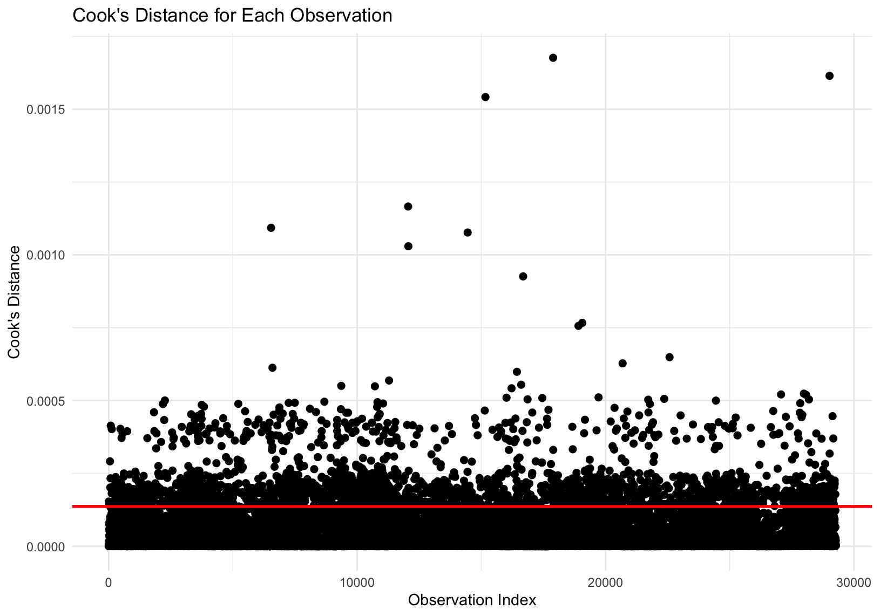
Figure 17: Cook's Distance for each observation in the sample. Source: Own elaboration.

Therefore, Table 9. presents the results of logistic regression analysis after excluding influential points. It can be observed that McFadden R² improved significantly from 13.5 to 36.2 percent. Although removing influential observations from the dataset may be justified if their presence substantially impacts the overall fit of the model, excluding them may still not be an optimal solution. Influential points are not always problematic, as they might store some valuable information (Belsley et al., 1980). Moreover, standard errors of coefficients in the Model 2 are higher than those in the Model 1. Therefore, the initial logistic regression model (Model 1) seems to prevail.

Logistic Regression Results (Model 2)
Predictors | Coefficient | Std. Error | t-statistic | p-value | CI Lower | CI Upper
(Intercept) | -2.639 | 0.128 | -20.6064374 | 0.000 | -2.891 | -2.389
polintr_reversed2 | 1.005 | 0.044 | 23.0106582 | 0.000 | 0.920 | 1.091
polintr_reversed3 | 7.613 | 0.708 | 10.7507678 | 0.000 | 6.483 | 9.409
polintr_reversed4 | 17.375 | 99.348 | 0.1748883 | 0.861 | 151.449 | 128.740
gender1 | -0.098 | 0.044 | -2.2331739 | 0.026 | -0.185 | -0.012
eduyrs | 0.154 | 0.007 | 21.5457545 | 0.000 | 0.140 | 0.169
atchctr | 0.145 | 0.009 | 15.3753682 | 0.000 | 0.127 | 0.164
age_16_29 | -1.316 | 0.070 | -18.6781338 | 0.000 | -1.454 | -1.178
age_30_49 | -0.858 | 0.059 | -14.6294730 | 0.000 | -0.973 | -0.743
age_65plus | 0.751 | 0.068 | 11.0549386 | 0.000 | 0.618 | 0.884
d2 | 0.444 | 0.062 | 7.2114410 | 0.000 | 0.323 | 0.565
d3 | 0.637 | 0.066 | 9.6901421 | 0.000 | 0.508 | 0.766
d4 | 0.707 | 0.070 | 10.1369331 | 0.000 | 0.570 | 0.843
d5 | 1.388 | 0.093 | 14.8822819 | 0.000 | 1.206 | 1.572
Observations | 27 144
McFadden R² | 0.362

Table 9: Logistic Regression Results (Model 2). Source: Own elaboration.

Discussion of results
Since all predictors are statistically significant, odds ratios can be computed to assess their effect on probability of voting in national elections (Table 10.).

Odds Ratios (Model 1)
Predictors | Odds Ratio | CI Lower | CI Upper
polintr_reversed2 | 2.09 | 1.940 | 2.259
polintr_reversed3 | 5.02 | 4.585 | 5.500
polintr_reversed4 | 6.81 | 5.903 | 7.873
gender | 0.92 | 0.859 | 0.977
eduyrs | 1.08 | 1.071 | 1.091
atchctr | 1.11 | 1.093 | 1.123
age_16_29 | 0.44 | 0.394 | 0.485
age_30_49 | 0.63 | 0.582 | 0.688
age_65plus | 1.47 | 1.342 | 1.616
d2 | 1.38 | 1.257 | 1.522
d3 | 1.51 | 1.372 | 1.672
d4 | 1.67 | 1.507 | 1.855
d5 | 1.90 | 1.680 | 2.129

Table 10: Odds Ratios (Model 1). Source: Own elaboration.

The odds ratios help to identify the likelihood that a particular exposure will result in a specific outcome (Tenny et al. 2023). In other words, odds ratio is a statistic that measures the odds of an event occurring in one group, compared to the odds of it occurring in another group. Firstly, when it comes to political interest, people who declared that they are “not interested in politics at all” serve as a reference category in this study. Therefore, by looking at odds ratio for variable polintr_reversed2, it can be concluded that people who are “hardly interested” in politics have 2.09 times higher odds of participating in national elections in comparison to those that are “not interested at all”. In other words, a person “hardly interested” in politics has 109 percent higher likelihood to vote than the one that is “not interested at all”. Moreover, individuals that are “quite interested” in politics (polintr_reversed3) are 5.02 times more likely to vote than the reference group. Finally, people that are “very interested” in politics have 6.81 times higher odds of voting than those who are “not interested at all”.
Then, when it comes to gender, females appear to be slightly more likely to vote. Hence, the odds of voting for males are about 8 percent lower than for females. Regarding education, for every additional year of education, the likelihood of voting increases by 8 percent (odds ratio equal to 1.08). As far as attachment to a country is concerned, an additional one-point increase on the Likert scale indicates an 11 percent increase in the odds of casting a ballot (odds ratio equal to 1.11).
Moving on to age, individuals aged from 50 to 64 years serve as a reference group. Firstly, young people (aged from 16 to 29 years) are less likely to vote, with their odds of voting being 56 percent lower than those in reference group. Similarly, people aged from 30 to 49 years have lower probability of voting than the reference group. Their odds of participating in elections are 37 percent lower than those aged from 50 to 64 years. Finally, people above 65 years old appear to be most likely to vote, with their odds of voting being 47 percent higher in comparison with the reference group.
Odds ratios for specific income groups can be analyzed as well. In this case, the poorest individuals from the first and second decile serve as a reference group (d1). Hence, people who are in the third and fourth deciles (d2) are 38 percent more likely to vote (odds ratio equal to 1.38). Moreover, people from fifth and sixth deciles (d3) have 51 percent higher odds of voting in elections in comparison with the poorest individuals. Then, the odds for people in seventh and eighth deciles (d4) are 67 percent higher than for those with the lowest incomes. Finally, the wealthiest people from ninth and tenth deciles (d5) are characterized by 90 percent higher odds of voting in comparison to the poorest.

Conclusion

Confrontation of results with literature

Bibliography:

- Andrade, C., 2021. A Student’s Guide to the Classification and Operationalization of Variables in the Conceptualization and Design of a Clinical Study: Part 2. Indian Journal of Psychological Medicine 43, 265–268. https://doi.org/10.1177/0253717621996151
- Becker, R., 2022. Gender and Survey Participation An Event History Analysis of the Gender Effects of Survey Participation in a Probability-based Multi-wave Panel Study with a Sequential Mixed-mode Design. methods&#44; data&#44; analyses 16, 29 Pages. https://doi.org/10.12758/MDA.2021.08
- Belsley, D.A., Kuh, E., Welsch, R.E., 1980. Regression diagnostics: identifying influential data and sources of collinearity, Wiley series in probability and mathematical statistics. Wiley, New York.
- Berinsky, A.J., Lenz, G.S., 2011. Education and Political Participation: Exploring the Causal Link. Polit Behav 33, 357–373. https://doi.org/10.1007/s11109-010-9134-9
- Brady, H.E., Verba, S., Schlozman, K.L., 1995. Beyond SES: A Resource Model of Political Participation. Am Polit Sci Rev 89, 271–294. https://doi.org/10.2307/2082425
- Chang, W.-C., 2014. Income, Electoral Turnout, and Partisan Voting in Taiwan. Journal of East Asian Studies 14, 347–376. https://doi.org/10.1017/S159824080000552X
- Crothers, L., Lockhart, C. (Eds.), 2000. Culture and Politics: A Reader. Palgrave Macmillan US, New York. https://doi.org/10.1007/978-1-349-62965-7
- Dalton, R.J., 2008. Citizenship Norms and the Expansion of Political Participation. Political Studies 56, 76–98. https://doi.org/10.1111/j.1467-9248.2007.00718.x
- Dassonneville, R., Kostelka, F., 2021. The Cultural Sources of the Gender Gap in Voter Turnout. Brit. J. Polit. Sci. 51, 1040–1061. https://doi.org/10.1017/S0007123419000644
- Filer, J.E., Kenny, L.W., Morton, R.B., 1993. Redistribution, Income, and Voting. American Journal of Political Science 37, 63. https://doi.org/10.2307/2111524
- Glenn, N.D., Grimes, M., 1968. Aging, Voting, and Political Interest. American Sociological Review 33, 563. https://doi.org/10.2307/2092441
- Huddy, L., Khatib, N., 2007. American Patriotism, National Identity, and Political Involvement. American J Political Sci 51, 63–77. https://doi.org/10.1111/j.1540-5907.2007.00237.x
- Iacobucci, D., Román, S., Moon, S., Rouziès, D., 2025. A Tutorial on What to Do With Skewness, Kurtosis, and Outliers: New Insights to Help Scholars Conduct and Defend Their Research. Psychology and Marketing mar.22187. https://doi.org/10.1002/mar.22187
- James, G., Witten, D., Hastie, T., Tibshirani, R., 2013. An Introduction to Statistical Learning, Springer Texts in Statistics. Springer New York, New York, NY. https://doi.org/10.1007/978-1-4614-7138-7
- Kattimani, D.S.R., n.d. THE IMPACT OF EDUCATION ON POLITICAL PARTICIPATION – A REVIEW 10.
- Kim, Y., 2023. Absolutely Relative: How Education Shapes Voter Turnout in the United States. Soc Indic Res 168, 447–469. https://doi.org/10.1007/s11205-023-03146-1
- Krzyśko, M., Smaga, Ł., 2018. Selected Robust Logistic Regression Specification for Classification of Multi‑dimensional Functional Data in Presence of Outlier. Folia Oeconomica 2. https://doi.org/10.18778/0208-6018.334.04
- Levy, B.L.M., Akiva, T., 2019. Motivating Political Participation Among Youth: An Analysis of Factors Related to Adolescents’ Political Engagement. Political Psychology 40, 1039–1055. https://doi.org/10.1111/pops.12578
- Lijphart, A., 1997. Unequal Participation: Democracy’s Unresolved Dilemma. The American Political Science Review 91, 1–14. https://doi.org/10.2307/2952255
- Martikainen, P., Martikainen, T., Wass, H., 2005. The effect of socioeconomic factors on voter turnout in Finland: A register‐based study of 2.9 million voters. European J Political Res 44, 645–669. https://doi.org/10.1111/j.1475-6765.2005.00242.x
- McDonald, B., 2002. A Teaching Note on Cook’s Distance – A Guideline. Research Letters in the Information and Mathematical Sciences 3, 122–128.
- Midi, H., Sarkar, S.K., Rana, S., 2010. Collinearity diagnostics of binary logistic regression model. Journal of Interdisciplinary Mathematics 13, 253–267. https://doi.org/10.1080/09720502.2010.10700699
- Milligan, K., Moretti, E., Oreopoulos, P., 2004. Does education improve citizenship? Evidence from the United States and the United Kingdom. Journal of Public Economics 88, 1667–1695. https://doi.org/10.1016/j.jpubeco.2003.10.005
- Palaščáková, L., 2020. THE RELATIONSHIP BETWEEN EDUCATION, EMPLOYMENT AND INCOME. EEiM 55, 7–21. https://doi.org/10.33119/EEIM.2020.55.1
- Potgieter, E., 2013. PREDICTORS OF POLITICAL PARTICIPATION IN NEW DEMOCRACIES: A COMPARATIVE STUDY.
- Powell, G.B., 1986. American Voter Turnout in Comparative Perspective. Am Polit Sci Rev 80, 17–43. https://doi.org/10.2307/1957082
- Ratner, B., 2009. The correlation coefficient: Its values range between +1/−1, or do they? J Target Meas Anal Mark 17, 139–142. https://doi.org/10.1057/jt.2009.5
- Rhemtulla, M., Brosseau-Liard, P.É., Savalei, V., 2012. When can categorical variables be treated as continuous? A comparison of robust continuous and categorical SEM estimation methods under suboptimal conditions. Psychological Methods 17, 354–373. https://doi.org/10.1037/a0029315
- Rose, R., n.d. 2. Voter Turnout in the European Union Member Countries.
- Rosenstone, S.J., 1982. Economic Adversity and Voter Turnout. American Journal of Political Science 26, 25. https://doi.org/10.2307/2110837
- Salas-Eljatib, C., Fuentes-Ramirez, A., Gregoire, T.G., Altamirano, A., Yaitul, V., 2018. A study on the effects of unbalanced data when fitting logistic regression models in ecology. Ecological Indicators 85, 502–508. https://doi.org/10.1016/j.ecolind.2017.10.030
- Schafer, J., Cantoni, E., Bellettini, G., Berti Ceroni, C., 2022. Making Unequal Democracy Work? The Effects of Income on Voter Turnout in Northern Italy. American J Political Sci 66, 745–761. https://doi.org/10.1111/ajps.12605
- SchöPflin, G., 1990. The end of communism in Eastern Europe. International Affairs 66, 3–16. https://doi.org/10.2307/2622187
- Shrestha, N., 2020. Detecting Multicollinearity in Regression Analysis. AJAMS 8, 39–42. https://doi.org/10.12691/ajams-8-2-1
- Smets, K., Van Ham, C., 2013. The embarrassment of riches? A meta-analysis of individual-level research on voter turnout. Electoral Studies 32, 344–359. https://doi.org/10.1016/j.electstud.2012.12.006
- Snyder, R., 2011. The impact of age, education, political knowledge and political context on voter turnout. UNLV Theses, Dissertations, Professional Papers, and Capstones 1400. https://doi.org/10.34917/3310658
- Solijonov, A., 2016. Voter Turnout Trends around the World.
- Stockemer, D., Sundstrom, A., 2023. The gender gap in voter turnout: An artefact of men’s over-reporting in survey research? The British Journal of Politics and International Relations 25, 21–41. https://doi.org/10.1177/13691481211056850
- Tambe, E.B., 2016. Who Votes in East Asia? Eur J East Asian Stud 15, 149–173. https://doi.org/10.1163/15700615-01502006
- Valenzuela, S., Bachmann, I., 2017. Path Analysis, in: Matthes, J., Davis, C.S., Potter, R.F. (Eds.), The International Encyclopedia of Communication Research Methods. Wiley, pp. 1–9. https://doi.org/10.1002/9781118901731.iecrm0181
- Wooldridge, J.M., 2012. Introductory Econometrics: A Modern Approach.

NEED TO BE ADDED TO BIBLIOGRAPHY:

https://www.independent.co.uk/news/uk/home-news/britain-s-young-people-less-patriotic-than-older-generation-10390185.html
https://builtin.com/data-science/when-and-why-standardize-your-data
Verba, S., & Nie, N. H. (1972). Participation in America: Political Democracy and Social Equality. New York: Harper & Row.
WOLFINGER, R. E., & ROSENSTONE, S. J., 1980. Who Votes? Yale University Press. http://www.jstor.org/stable/j.ctt32bffz

https://www.numberanalytics.com/blog/comprehensive-guide-mcfaddens-r-squared-logistic-regression
https://www.numberanalytics.com/blog/using-cooks-distance-advanced-outlier-detection
Tenny S, Hoffman MR. Odds Ratio. 2023 May 22. In: StatPearls [Internet]. Treasure Island (FL): StatPearls Publishing; 2025 Jan–. PMID: 28613750.
https://www.idea.int/data-tools/data/voter-turnout-database
Bergson, A., (1958). [Review of An Economic Theory of Democracy, by A. Downs]. The American Economic Review, 48(3), 437–440. http://www.jstor.org/stable/1809781

https://ec.europa.eu/eurostat/statistics-explained/index.php?title=Gender_pay_gap_statistics
https://www.europarl.europa.eu/topics/en/article/20200109STO69925/understanding-the-gender-pay-gap-definition-facts-and-causes

List of tables:
Table 1: Age categorization. Source: Own elaboration. 14
Table 2: Income recategorization. Source: Own elaboration. 16
Table 3: Summary of all variables needed for the analysis. Source: Own elaboration. 18
Table 4: Coding of responses regarding voting in the last national elections. Source: Own elaboration. 20
Table 5: Descriptive statistics for variable age. Source: Own elaboration 23
Table 6: Descriptive statistics for variable eduyrs. Source: Own elaboration. 25
Table 7: Logistic regression results (Model 1). Source: Own elaboration. 29
Table 8: Variance Inflation Factor (VIF) - summary for Model 1. Source: Own elaboration. 30
Table 9: Logistic Regression Results (Model 2). Source: Own elaboration. 32
Table 10: Odds Ratios (Model 1). Source: Own elaboration. 33

List of figures:
Figure 1: Direct relationships between the predictors and dependent variable. Source: Own elaboration. 10
Figure 2: Path 1: Indirect relationships between predictors and dependent variable. Source: Own elaboration. 11
Figure 3: Path 2: Indirect relationships between predictors and dependent variable. Source: Own elaboration. 11
Figure 4: Path 3: Indirect relationships between predictors and dependent variable. Source: Own elaboration. 12
Figure 5: Path 4: Indirect relationships between predictors and dependent variable. Source: Own elaboration. 12
Figure 6: Relationship between the log odds of voting and age. Source: Own elaboration. 13
Figure 7: Relationship between the log odds of voting and education years. Source: Own elaboration. 15
Figure 8: Survey participation rate by country. Source: Own elaboration. 20
Figure 9: Share of respondents who voted and abstained in the last national elections. Source: Own elaboration. 22
Figure 10: Distribution of age in the sample. Source: Own elaboration 23
Figure 11: Age categories in the sample. Source: Own elaboration. 24
Figure 12: Distribution of education years (eduyrs) in the sample. Source: Own elaboration. 25
Figure 13: Political interest among respondents. Source: Own elaboration. 26
Figure 14: Income distribution in the sample. Source: Own elaboration. 26
Figure 15: Attachment to a country in the sample. Source: Own elaboration. 27
Figure 16: Share of men and women in the sample. Source: Own elaboration. 28
Figure 17: Cook's Distance for each observation in the sample. Source: Own elaboration. 31

Summary
(orientacyjnie 900 znaków)

Statement should be uploaded to APD as separate file

Annex No. 2 to the Rules for Verifying Independent Preparation and Electronic Archiving of Diploma Theses
STATEMENT OF AUTHOR OF THE BACHELOR’S/MASTER’S DIPLOMA
THESIS/THESIS CHAPTERS*
titled
written by: Student number

supervised by
Aware of the legał liability, I hereby declare this diploma thesis to have been written by myself independently and not to include any unlawfully acquired content.
I also State that the submitted diploma thesis has never been subject to any procedures aimed at obtaining a professional title at any university.
Additionally, I confirm that this version of the diploma thesis is identical with the attached electronic version.

.............................................................. …..........................................................
(date) (author's signature)

In the logistic regression, the value of responses regarding voting coded “2” (No) was changed into “0”. Such operation allowed for creation of binary (dichotomous) variable.

